**Chapter 8 exercise – installing Hyper-V on Windows Server 2019**

In this exercise, you will learn how to install the Hyper-V role on Windows Server 2019.

## Prepare for Nested Virtualization.

1. In Hyper-V Manager, right click SVR2, choose Settings, and then, under Hardware, click “Memory” and remove “Enable Dynamic Memory”.
2. Open an administrative PowerShell prompt by right clicking the Windows button on the host machine and choose “Windows PowerShell (Admin).
3. In the PowerShell prompt, write in one command: Set-VMProcessor -VMName SVR2   
   -ExposeVirtualizationExtensions $true.
4. Start SVR2.

## Installing the Hyper-V role on Windows Server 2019

To install the Hyper-V role on Windows Server 2019 using the Server Manager, complete the following steps:

1. Click the Start button, and then, in the Start menu, click **Server Manager**.
2. In the **Server Manager** window, click the **Add roles and features** hyperlink.
3. In the **Before You Begin** option, click **Next**.
4. In the **Installation Type** option, click **Next**.
5. In the **Server Selection** option, click **Next**.
6. Select the **Hyper-V** role, as shown in *Figure 8.17*:

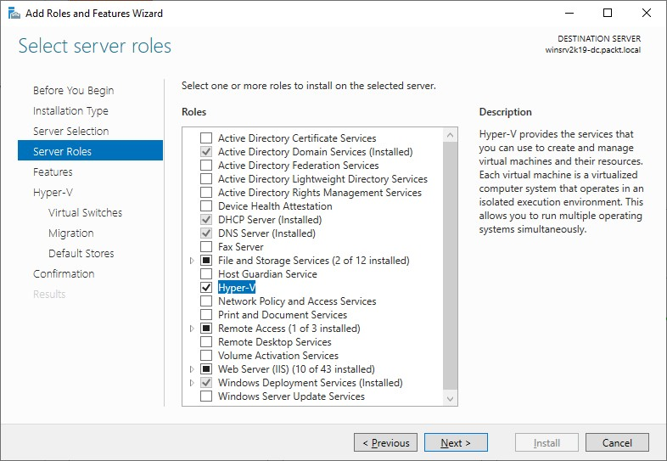

Figure 8.17: Selecting the Hyper-V role

1. Click the **Add Features** button to add features that are required for Hyper-V.
2. There is no feature to add, so click **Next**.
3. In the Hyper-V definition option, click **Next**.
4. Select the available network adapter, and then click **Next**.
5. Select **Allow this server to send and receive live migrations of virtual machines** and click **Next**.
6. Set up the path where you will store the VMs and click **Next**.
7. Confirm the installation selections for the Hyper-V role by clicking **Install**.
8. When the installation process completes, click **Close** (see *Figure 8.18*). The server will restart automatically:

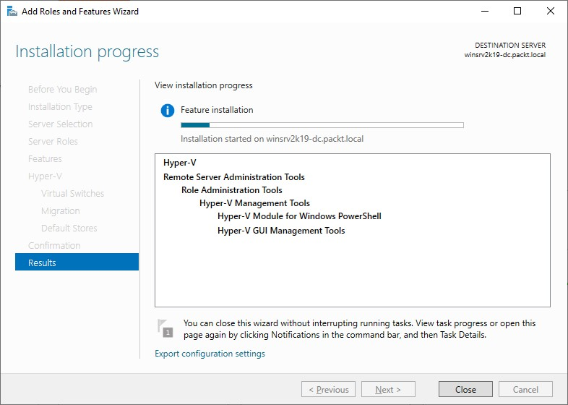

Figure 8.18: Installing the Hyper-V role on Windows Server 2019

The Hyper-V role will now be installed and is ready to use.

1. After restart, sign in and see if you can create a virtual machine.